1. As the number of calls to our microservice increase, we will be scaling up the microservice. That means we will be deploying different instances of a microservice across different servers and a request would be sent to one of these instances.
2. Spring Cloud provides a load balancer component which works very closely automatically with the Feign Client to do client side load balancing.  
   This client side load balancer will decide to which instance of a microservice this request should go to.
3. 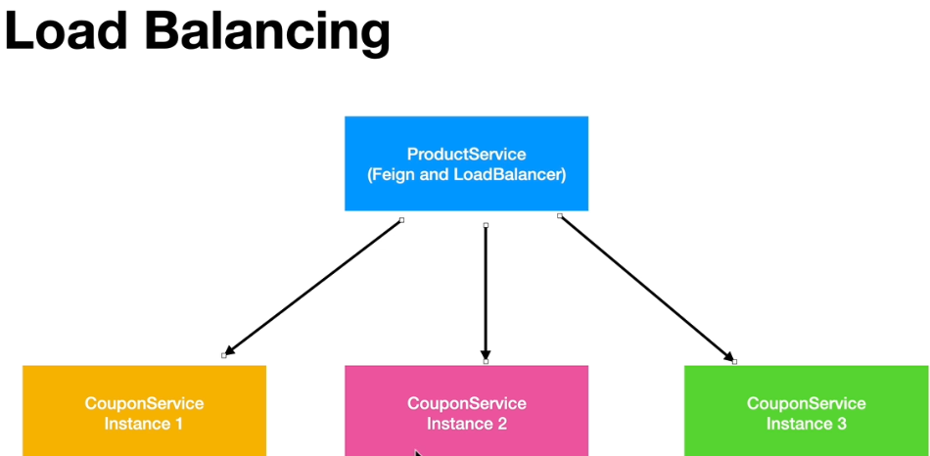
4. 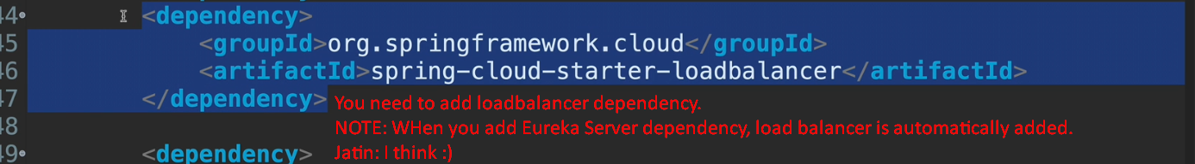
5. 